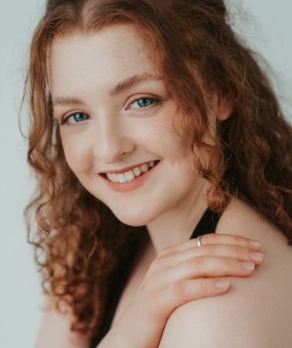
Anna Stidolph

Email: anna@annastidolph.com

Phone: 07400059065

Website: www.annastidolph.com

Personal Details:
Height | 5’3”
Build | Petite
Eyes | Blue
Hair | Red
Playing Age | 16-26
Voice | Soprano
Nationality | British
Equity | 00467934
Spotlight | 3570-8974-5742
Training:
The MGA Academy of Performing Arts (2017-2020)
BA (Hons) Dance for Commercial Performance

JPA Private Acting Coaching (Since 2021)
Credits:
FILM AND TELEVISION
Production |  | Role |  | Company | Director
‘Easy A’ |  | Olive (Lead) |  | Twin City Productions | John P Arnold
‘Brave’ |  | Merida (Lead) |  | Twin City Productions | John P Arnold
‘Influenced’ |  | Stargirl (Lead) |  | James Patterson | James Patterson
‘Seventh Savior’ |  | Lucy (Lead) |  | AJ Pimms Productions | AJ Pimms
‘Shadow of Secrets’ |  | Ruby (Lead) |  | AJ Pimms Productions | AJ Pimms
Yours Always, John’ |  | Anne (Lead) |  | Lara Mepham Productions | Lara Mepham
‘Spiderlily’ |  | Beautiful Bearded Lady |  | Andromeda Pictures | Amber Gray
‘The Straw’ |  | Eileen (Lead) |  | Twin City Productions | John P Arnold
‘Fairytales’ |  | Meredith (Lead) |  | Twin City Productions | John P Arnold
THEATRE
Production |  | Role |  | Venue | Director
‘The Evans and Peel Detective Agency’ |  | Detective Volkova |  | The Evans and Peel Detective Agency | Jason Davies
‘Chapters’ |  | Dancer |  | Leith Theatre | Sup Dhanasunthorn
‘Fire Up Scotland’ |  | Dancer |  | The SSE Hydro | Alexandra Risbridger
‘A Christmas Wish’ |  | Featured Dancer |  | Usher Hall | Marcella Macdonald

Skills:

Accents: Aberdeen (Native), Edinburgh, Scottish-Standard, English-Standard, American-California

Dance: Jazz, Ballet, Modern, Lyrical, Contemporary, Pointe, Commercial, Latin, Tap, and Hip-Hop

Other: Aerial, Swimming, Skiing, Yoga, Pilates, Lifeguarding, Personal Training, Fitness Instructing, First Aid

Valid UK Passport Holder

Full Driving License

Full PVG

